ST PAUL’S UNIVERSITY
CAMPUS: LIMURU
UNIT NAME: Software engineering II

UNIT CODE: BCS 3106
LECTURE: Cecilia Nanfuka
Semester Project
Title: Project Objective and System Model for SDLC Guard, an SDLC Infrastructure Security Dashboard
GitHub Project Folder:
Group Name: GROUP IV
STUDENT NUMBER:
Bobitlmr342325
Bobitlmr335525
bobitlmr108825
BOBITLMR249222
BOBITLMR341725

1. Introduction and Background
Attackers are increasingly targeting the systems that build software rather than the finished application. Compromising CI/CD pipelines, build runners, IDEs, version control and registries lets an attacker scale impact across many applications at once. The SDLC Infrastructure Threat Framework (SITF) describes this "code factory" through five pillars: Endpoint/IDE, VCS, CI/CD, Registry and Production, and catalogues more than 75 attack techniques such as Action Cache Poisoning and Imposter Commits (Berkovich, S.); (Wiz, n.d.). Lean methodologies also underpin the system's operational workflow (Poppendieck, Mary; Poppendieck, Tom;, 2003).
Most organizations lack a single view of how exposed these pillars are. This project develops SDLC Guard, a Django-based security dashboard that gives engineering and security teams visibility of risk across the SDLC. The project follows Lean Software Development: eliminate waste, amplify learning, decide as late as possible, deliver as fast as possible, empower the team, build integrity in, and see the whole.
2. Project Objectives
2.1 Main Objective
To design and develop a secure web dashboard, using Python, Django and Matplotlib, that collects SDLC activity and security findings and presents them by SITF pillar so that teams can detect, prioritize and remediate threats to the software build and delivery process.
2.2 Specific Objectives
- Map findings and events from the five SITF pillars (Endpoint/IDE, VCS, CI/CD, Registry, Production) to known SITF attack techniques.
- Provide Matplotlib-based visualizations: findings by severity, findings by pillar, trend over time, SITF technique coverage and mean time to remediate.
- Support triage workflow: raising, assigning, updating and closing findings and remediation tasks.
- Enforce role-based access control (RBAC), authentication with optional MFA and an audit trail of user actions.
- Apply secure coding practices (input validation, parameterized ORM queries, CSRF/XSS protection, secure secrets handling, least privilege, dependency scanning).
- Deliver incrementally using Lean practices, tracked on Trello and GitHub Projects, with minimal viable features first.
2.3 Scope
- In scope: Data ingestion (CSV/JSON upload and GitHub API connector), dashboard, findings management, SITF catalogue, reporting/export, user management, audit log.
- Out of scope: Automated remediation of external systems, real-time agent installation on developer endpoints, and live production deployment.
3. System Model: Use Cases
3.3 Use Case Diagram
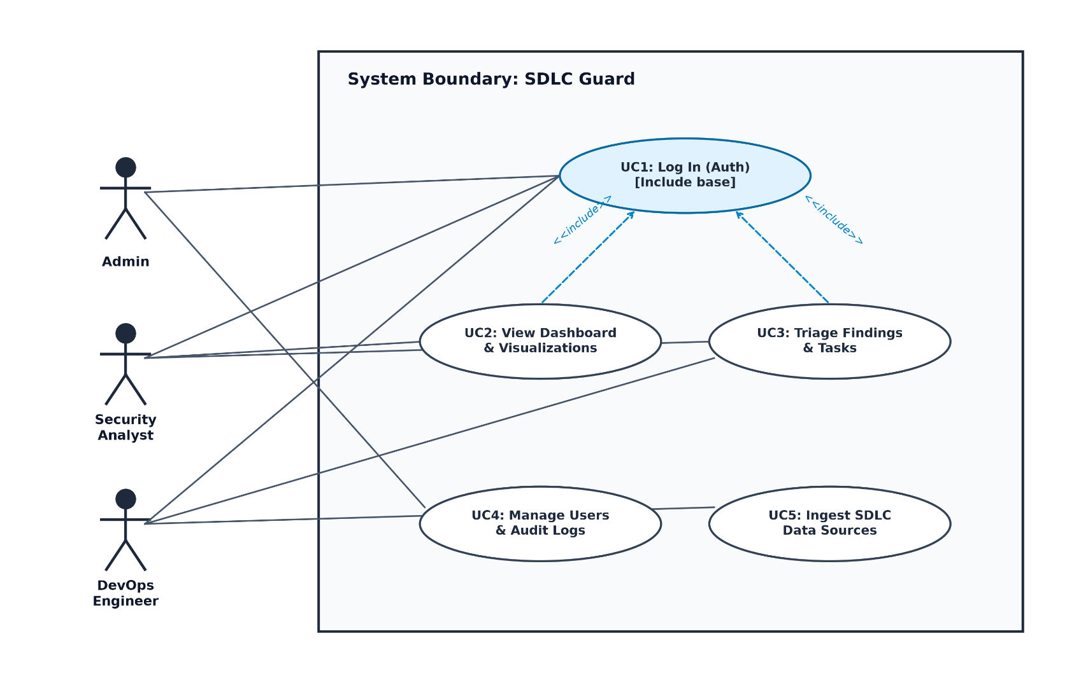
Admins configure the system, analysts and DevOps engineers work on findings, and every use case first requires UC1 (log in).
4. System Model: Class Diagram
4.1 Relationships
- A User has one Role; a Role is assigned to many Users.
- A Pillar has many Data Sources and many Techniques.
- A Data Source produces many Findings; each Finding maps to one Technique.
- A Finding has zero or more Remediation Tasks, each assigned to one User.
- An Alert Rule monitors one Pillar and is configured by an Admin User.
4.2 Class Diagram
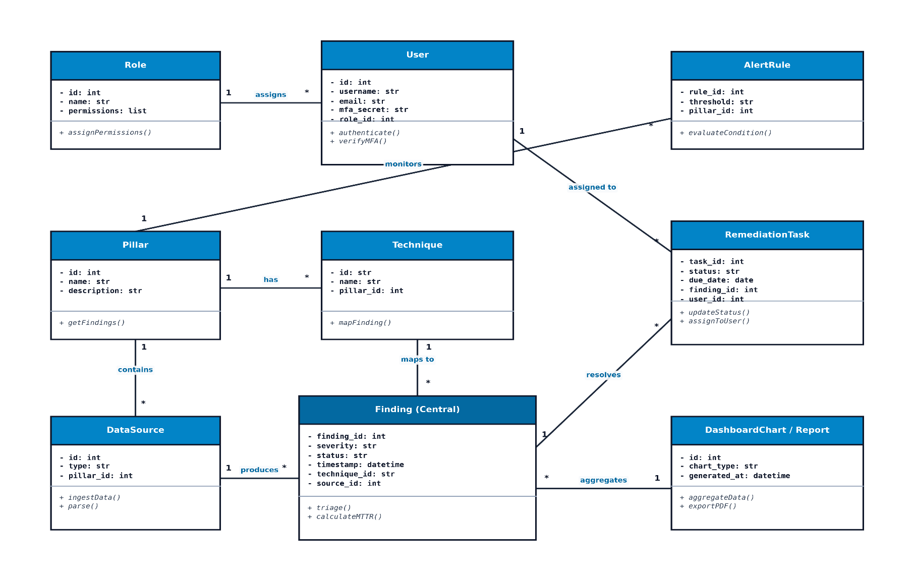
Finding is the central class: it links a data source, a SITF technique, remediation tasks and reports. Methods are listed in the table above; * means many.
5. Conclusion and Next Steps
This document defines the objective, scope and system model of SDLC Guard. The next deliverables are the Trello project plan, the SRS, the traceability matrix, the architecture and design document, and the test plan, followed by incremental development in Django with secure coding practices and Lean delivery cycles.

References
Berkovich, S. (n.d.). Securing the Code Factory: Why SDLC Infrastructure Has Become a Core Cloud Risk.
Poppendieck, Mary; Poppendieck, Tom;. (2003). Lean Software Development: An Agile Toolkit. Addison-Wesley.
Wiz. (n.d.). SDLC Infrastructure Threat Framework (SITF). Retrieved from https://wiz-sec-public.github.io/SITF/](https://wiz-sec-public.github.io/SITF

